LAB 8(A)
Tinker cad link: https://www.tinkercad.com/things/laJBviiqjwn-j-k-flip-flop/editel?sharecode=4bb_OSzyFNpdZyIUNyUZakWiPEoNQYnYmTc2VjXdmbY

Circuit diagram:
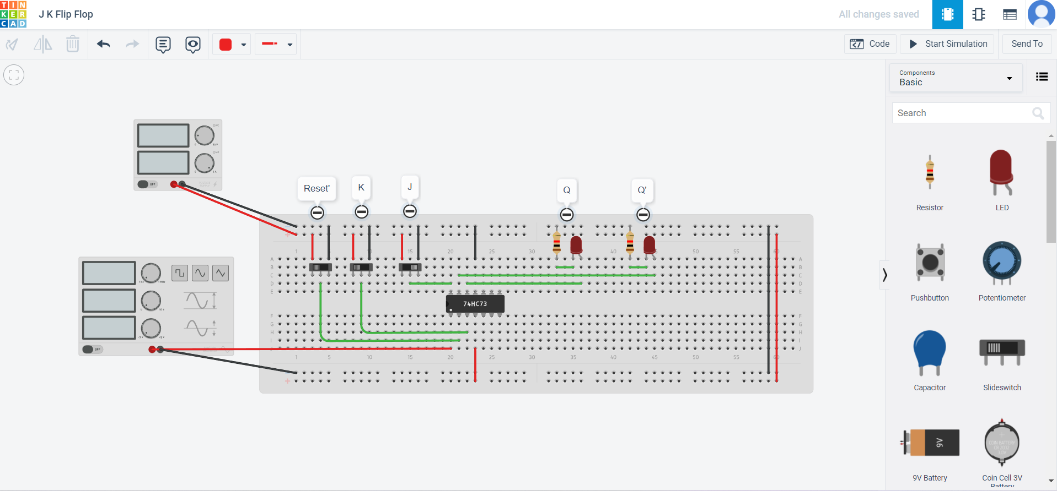

Pin diagram:
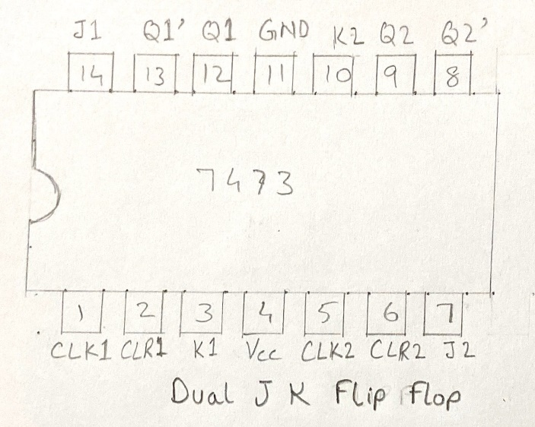

Truth Table:
Q(n) | J | K | Q(n+1)
0 | 0 | 0 | 0
0 | 0 | 1 | 0
0 | 1 | 0 | 1
0 | 1 | 1 | 1
1 | 0 | 0 | 1
1 | 0 | 1 | 0
1 | 1 | 0 | 1
1 | 1 | 1 | 0

Kmaps:
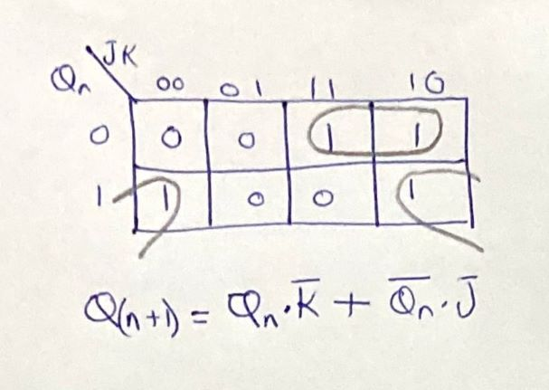

Characteristic Equation:
Q(n+1)=Q(n).K’ + Q(n)’.J
Observations:
J | K | Q | Q'
0 | 1 | 0 | 1
0 | 0 | 0 | 1
1 | 0 | 1 | 0
0 | 0 | 1 | 0
0 | 1 | 0 | 1
1 | 1 | toggle | toggle
1 | 0 | 1 | 0
1 | 1 | toggle | toggle
0 | 1 | 0 | 1

Justification:
The J K flip flop shows the above observations due to the table given below.The table below explains how the flip flop responds to different inputs.
clk | J | K | Q | Q'
on | 0 | 0 | hold | hold
on | 0 | 1 | 0 | 1
on | 1 | 0 | 1 | 0
on | 1 | 1 | toggle | toggle

Applications:
Used as registers for storing data in binary form.It used to make shift registers.
Used as counters for counting events or pulses.
Used as event detectors.The detectors change their state at start of an event and keep that state till it ends.

LAB 8(B)
Tinker cad link: https://www.tinkercad.com/things/iopmj2Avagi-lab-8-b/editel?sharecode=dgwOZ2lToZuShrupd-xKSYR4UmVwWLlC-TKhXv3oSoo

Circuit Diagram:
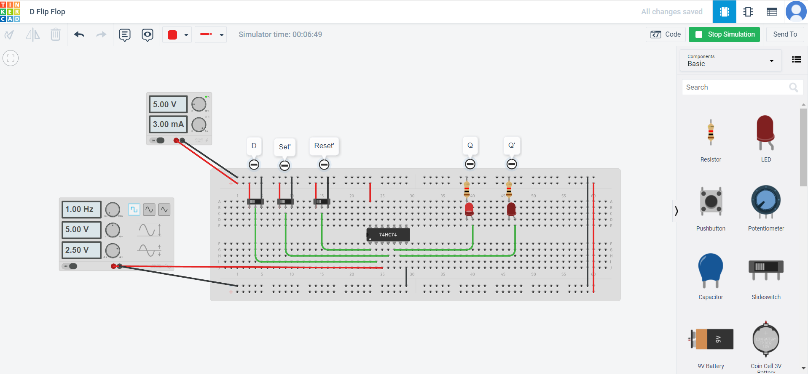

Pin Diagram:
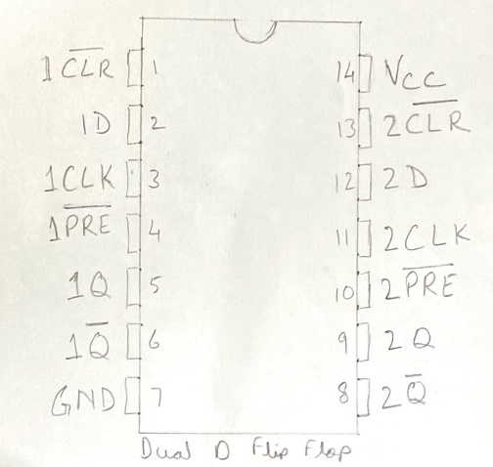

Truth Table:
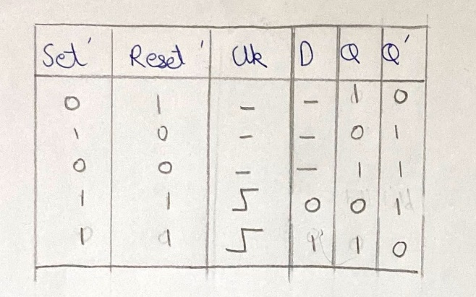
Kmaps:
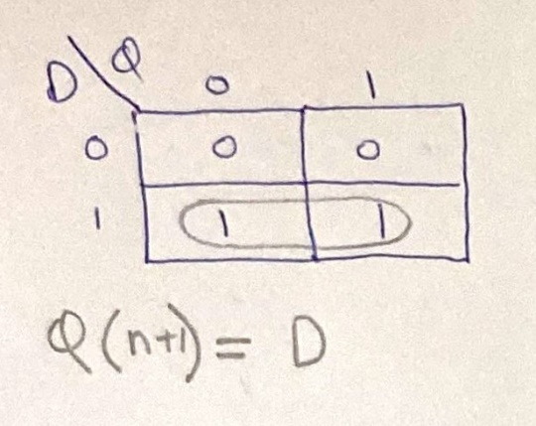

Characteristic Equation:
Q(n+1)=D

Observation and Justification:
clk | SET' | RESET' | D | Q | Q'
off | 0 | 0 | - | 1 | 1
off | 0 | 1 | - | 1 | 0
off | 1 | 0 | - | 0 | 1
off | 1 | 1 | - | hold | hold
on | 1 | 1 | 0 | 0 | 1
on | 1 | 1 | 1 | 1 | 0
on | 0 | 1 | - | 1 | 0
on | 1 | 0 | - | 0 | 1
on | 0 | 0 | - | 1 | 1

The D FF only gives two outputs 0 or 1 when the clock is on.This is because in case of D FF J=K’ so only two input cases are possible.When set’ is high Q’=1 and when Reset’ is high Q=1.
Applications:
Create delay lines.The D flip flop delays the output by one clock cycle.So it is used in circuits to delay the output.
Used as data synchronisers.Sometimes due to gate delays there is varying output which may cause undefined behaviour.The D FF latches on to the output until the next clock cycle.

